School of Engineering
Department of Computer Science and Engineering

EDUCATION AND AWARENESS – EFFECTIVE USE OF TECHNOLOY FOR DISSEMINATION OF ANTI-DOPING INFORMATION

A PROJECT REPORT
Submitted By

Dikshith S | - | 20231CSE3027
R V Babitha | - | 20221CSE0188
Arati Manakyal | - | 20221CSE0578

Under the guidance of,

Assistant Professor Ms. Nithya B.A
BACHELOR OF TECHNOLOGY

IN
COMPUTER SCIENCE AND ENGINEERING PRESIDENCY UNIVERSITY
BENGALURU DECEMBER 2025

Department of Computer Science and Engineering

BONAFIDE CERTIFICATE

Certified that this project titled “EDUCATION & AWARENESS- EFEECTIVE USE OF TENCHNOLOGY FOR DISSEMINATION OF ANTI-DOPING INFORMATION ” is a
bonafide work of “Dikshith S (20231CSE3027), R V Babitha (20221CSE0188), Arati Manakyal (20221CSE0578)”, who have successfully carried out the project work and submitted the report for partial fulfilment of the requirements for the award of the degree of Bachelor of Technology in Computer Science and Engineering during 2025-26.

Ms. Nithya B.A Project Guide Presidency University School of Computer Science and Engineering

Dr. Shakkeera L Associate Dean PSCS
Presidency University
Mr. Muthuraju V Program Project Coordinator PSCS Presidency University
Dr. Sampath A K Dr. Geetha A School Project
Coordinators PSCS Presidency Univeristy
Dr. S. Blessed Prince P Head of the Department Presidency University School of Computer Science and Engineering

Dr. Duraipandian N
Dean
PSCS & PSIS
Presidency University

Examiners

Sl. no. | Name | Signature | Date
1
2

DECLARATION

We the students of final year B.Tech in Computer Science and Engineering at Presidency University, Bengaluru, named Dikshith S, R V Babitha, Arati Manakyal hereby declare that the project titled “Education & Awareness- Effective use of Technology for Dissemination of Anti- Doping Information” has been independently carried out by us and submitted in partial fulfillment for the award of the degree of Bachelor of Technology in Computer Science and Engineering during the academic year of 2025-26. Further, the matter embodied in the project has not been submitted previously by anybody for the award of any Degree or Diploma to any other institution.

Dikshith S | - | 20231CSE3027
R V Babitha | - | 20221CSE0188
Arati Manakyal | - | 20221CSE0578

PLACE: BENGALURU
DATE: December 2025

ACKNOWLEDGEMENT
For completing this project work, We/I have received the support and the guidance from many people whom I would like to mention with deep sense of gratitude and indebtedness. We extend our gratitude to our beloved Chancellor, Vice Chancellor, Pro-Vice Chancellor, and Registrar for their support and encouragement in completion of the project.
I would like to sincerely thank my internal guide Ms. Nithya B, Assistant Professor, Department of Computer Science and Engineering, Presidency University, for her moral support, motivation, timely guidance and encouragement provided to us during the period of our project work.
I am also thankful to Dr. S Pravinth Raja, Professor, Head of the Department of Computer Science and Engineering, Presidency University, for his mentorship and encouragement.
We express our cordial thanks to Dr. Duraipandian N Dean, Dr. Shakkeera L Associate Dean, School of Engineering and entire of Presidency University for providing the required facilities and intellectually stimulating environment that aided in the completion of my project work.
We are grateful to Dr. Sampath A K and Dr. Geetha A., Project Coordinators, Department of Computer Science and Engineering, for facilitating research activities and timely assessments.
We are also grateful to Teaching and Non-Teaching staff of Department of Computer Science and Engineering and also staff from other departments who have extended their valuable help and cooperation.
Dikshth S
R V Babitha Arati Manakyal

Abstract

The integrity of sports relies heavily on fair play, ethical behavior, and the prevention of performance-enhancing drug misuse. In recent years, doping incidents have increased globally, highlighting the urgent need for effective education and awareness programs. Traditional methods of delivering anti-doping information—such as seminars, printed materials, and in- person workshops—often fail to reach a wider and diverse audience. With the rapid growth of digital technologies, there is a significant opportunity to enhance the reach, accessibility, and impact of anti-doping awareness initiatives.

This project explores the use of modern technological tools to disseminate anti-doping information in an efficient and user-friendly manner. The approach includes using digital platforms such as mobile applications, web portals, e-learning modules, and social media channels to educate athletes, students, coaches, and the public. Interactive features like videos, infographics, quizzes, and chatbots were designed to simplify complex information and improve user engagement. The project framework emphasizes accessibility, timely updates, and consistent messaging to ensure users receive accurate and reliable data regarding banned substances, testing procedures, health risks, and ethical sporting practices.

The results of the project demonstrate that technology-based dissemination significantly improves awareness levels compared to traditional methods. Users found digital tools more engaging, convenient, and easy to understand. The study concludes that integrating technology into anti-doping education can greatly enhance the effectiveness of awareness programs and contribute to promoting clean, fair, and responsible sporting environments.

Table of Content

Sl. No. | Title | Page No.
 | Declaration | III
 | Acknowledgement | IV
 | Abstract | V
 | List of Figures | VIII
 | List of Tables | IX
 | Abbreviations | X
1. | Introduction  - Background  - Statistics of Project  - Prior Existing Technologies  - Proposed Approach  - Objectives  - SDGs (Sustainable Development Goals)  - Overview of Project Report | 1-4
2. | Literature review | 5-9
3. | Methodology | 10-16
4. | Project management  - Project timeline  - Risk analysis  - Project budget | 17-21
5. | Analysis and Design  - Requirements  - Block Diagram  - System Flow Chart  - Choosing devices  - Designing units  - Standards  - Mapping with IoTWF reference model layers  - Domain model specification | 22-30

 | - Communication model  - IoT deployment level  - Functional view  - Mapping IoT deployment level with functional view  - Operational view  - Other Design | 31-33
6. | Hardware, Software and Simulation  - Hardware  - Software development tools  - Software code  - Simulation | 34-37
7. | Evaluation and Results  - Test points  - Test plan  - Test result  - Insights | 38-41
8. | Social, Legal, Ethical, Sustainability and Safety Aspects  - Social aspects  - Legal aspects  - Ethical aspects  - Sustainability aspects  - Safety aspects | 42-44
9. | Conclusion | 45-46
 | References | 47-48
 | Appendix | 49-54

Figure No. | Caption | Page No.
1.1 | Overview of Anti-Doping Awareness Gap | 2
1.2 | Structure of Digital Anti-Doping Education System | 4
2.1 | Anti-Doping Education Framework (Literature) | 5
2.2 | Technology-Enabled Learning Model | 6
3.1 | Proposed Methodology Framework | 10
3.2 | Phases of the Research Method | 11
4.1 | Project Timeline (Gantt Chart) | 18
4.2 | Risk Assessment Matrix | 19
4.3 | Project Budget Distribution | 20
5.1 | System Requirement Model | 23
5.2 | Block Diagram of Proposed Awareness System | 24
5.3 | System Flowchart | 25
5.4 | Device Selection Overview | 26
5.5 | Design Unit Interaction Diagram | 28
5.6 | Standards Mapping Framework | 29
5.7 | IoTWF Layer Mapping Model | 29
5.8 | Domain Model Specification | 30
5.9 | Communication Model Diagram | 31
5.1 | IoT Deployment Level Classification | 31
5.11 | Functional View of the System | 32
5.12 | Mapping Functional View to IoT Deployment | 33
5.13 | Operational View Diagram | 33
7.1 | Test Points Overview Diagram | 38
7.2 | Test Plan Flowchart | 39
7.3 | Test Result – Pass/Fail Chart | 40
7.4 | Insights & Performance Improvement Diagram | 41

Table ID | Table Caption | Page No.
Table 2.1 | Summary of Literature Reviews | 5
Table 4.2 | Project Planning Timeline | 18
Table 4.3 | Project Budget | 20
Table 7.2 | Test Plan | 39

List of Abbreviations
Abbreviation | Full Form
AI | Artificial Intelligence
ATP | Anti-Doping Testing Procedures
CSS | Cascading Style Sheets
DOM | Document Object Model
E-Learning | Electronic Learning
HCI | Human–Computer Interaction
HTML | Hypertext Markup Language
ICT | Information and Communication Technology
IEEE | Institute of Electrical and Electronics Engineers
IoT | Internet of Things
ISE | International Standard for Education (WADA)
JS | JavaScript
NADA | National Anti-Doping Agency
SDG | Sustainable Development Goal
TDP | Test Distribution Plan
TUE | Therapeutic Use Exemption
UI | User Interface
UN | United Nations
UX | User Experience
WADA | World Anti-Doping Agency

Chapter 1

Introduction
The field of sports has undergone significant transformation over the last few decades, becoming increasingly competitive, professional, and globally interconnected. As athletes strive for higher levels of performance, the pressure to excel has intensified. Alongside this growth, the misuse of performance-enhancing substances—commonly referred to as doping—has emerged as one of the most critical challenges confronting modern sport. Doping not only undermines the foundational principles of fairness and integrity but also poses severe risks to the physical and psychological well-being of athletes. In response, international and national bodies have implemented comprehensive regulatory frameworks to preserve the spirit of clean competition.

Despite continuous regulatory advancements, the issue persists largely due to widespread gaps in awareness, limited access to reliable information, and misconceptions regarding supplements and medical substances. A substantial number of doping violations occur unintentionally, particularly among young, amateur, and rural athletes who lack formal exposure to anti-doping rules. Traditional awareness programs, such as seminars and printed guidelines, often fall short in reaching diverse and geographically dispersed populations. Moreover, frequent updates to anti-doping regulations make it difficult for athletes to rely solely on static or offline resources.

Rapid technological advancements have created new opportunities for modernizing anti-doping education. Digital platforms, including mobile applications, interactive web portals, e-learning tools, and social media channels, can significantly enhance the reach, accessibility, and effectiveness of awareness initiatives. These tools enable continuous, user-friendly learning and provide accurate information in real time. The integration of technology into anti-doping communication can therefore play a pivotal role in reducing misinformation and promoting ethical sports culture.

This chapter provides an overview of the need for technology-driven dissemination of anti-doping information. It discusses the background of the problem, the changing dynamics of sports education, existing awareness gaps, and the potential benefits of adopting digital solutions. The chapter further outlines the objectives, scope, and structure of the project, establishing the foundation for subsequent sections of the report.

  - Background
The concept of fair play forms the moral foundation of competitive sport. Athletes are expected to rely solely on their natural abilities, hard work, and discipline to achieve excellence. However, the growing misuse of performance-enhancing substances has

placed significant pressure on the global sports community. This practice, commonly referred to as doping, threatens not only the credibility of sports but also the health and well-being of athletes. To counter these challenges, international and national organizations such as the World Anti-Doping Agency (WADA) and the National Anti- Doping Agency (NADA) have established detailed rules, testing mechanisms, and educational campaigns.
Although regulations exist, a major gap persists in the area of awareness and understanding. Many athletes, especially younger or amateur competitors, are unsure about the list of prohibited substances, the risks associated with unregulated supplements, and the consequences of violating anti-doping rules. A considerable number of violations occur due to misinformation or lack of proper guidance rather than deliberate attempts to cheat. Traditional awareness programs—mainly physical workshops or printed brochures—often fail to reach diverse and geographically spread- out athlete groups. These approaches also struggle to keep pace with frequently updated anti-doping rules.
The rapid advancement of digital technologies offers new possibilities to improve the way anti-doping information is delivered. Mobile applications, websites, interactive learning modules, and social media platforms make it possible to communicate complex information in simplified formats. These tools can be accessed anytime and from anywhere, making them especially useful for athletes in remote regions. The present project examines how technology can be strategically used to strengthen anti- doping education and ensure more consistent, reliable, and engaging dissemination of information.

Statistics of the Project
Doping remains a global challenge despite years of regulatory intervention. WADA conducts hundreds of thousands of tests every year, and a notable number of samples still return adverse analytical findings. India has featured prominently in international doping statistics, indicating the need for stronger awareness initiatives across the country. Research suggests that many athletes who test positive are unaware of the ingredients in health supplements or medications they consume.
Additionally, survey-based studies reveal that a large portion of athletes—particularly those in schools, colleges, and local training academies—have never received formal instruction related to anti-doping rules. Many rely on informal advice from peers or coaches, which is not always accurate. In contrast, the adoption of digital education tools in other fields has shown positive outcomes such as higher learner engagement, faster recall, and better understanding. Technology-enhanced learning is found to reach significantly more people than conventional face-to-face training sessions.

Prior Existing Technologies
Several anti-doping agencies have already developed digital platforms to supplement traditional awareness methods. WADA’s e-learning system (ADeL) offers online modules for different categories of sports participants. NADA India has introduced a mobile application that provides access to anti-doping rules, lists of prohibited substances, and testing-related information. In addition to these resources, many organizations conduct online seminars, publish guidelines on official websites, and release awareness videos on social media.
However, these existing solutions face multiple challenges. Many platforms provide content only in English, limiting accessibility for regional learners. Some interfaces are highly technical and not easy for first-time users to navigate. Others lack features such as progress tracking, interactive quizzes, or instant assistance. Social media initiatives, while useful for outreach, often lack structure and continuity. These shortcomings highlight the need for a more comprehensive, user-friendly, and integrated digital system dedicated to anti-doping awareness.

Proposed Approach
The project proposes a multi-component, technology-driven framework designed to create a continuous and accessible anti-doping education system. The first component consists of a mobile application intended to deliver simplified learning modules, short informational videos, notification updates, and a searchable database of banned substances and testing guidelines. The second component involves a dedicated web platform that hosts structured learning content, infographics, policies, and extended reading material.
Furthermore, the approach integrates the use of social media for spreading short, focused educational messages that are easy to understand and share. Another key feature includes an AI-based chatbot capable of responding to common queries related to doping rules, supplement safety, testing procedures, and therapeutic exemptions. Together, these components aim to build an interactive, accessible, and scalable digital ecosystem that provides reliable anti-doping information to diverse audiences.

Objectives
The objectives of the project are theoretical, exploratory, and developmental in nature. The major aims include:
    - To conceptualize a digital learning ecosystem capable of improving awareness about anti-doping rules and ethical sporting behavior.
    - To provide athletes, students, and coaches with accurate and easily accessible information on banned substances, testing guidelines, and the health impacts of doping.

    - To minimize unintentional doping cases by equipping users with the knowledge required to make informed decisions.
    - To incorporate interactive and technology-enhanced educational tools such as mobile learning, infographics, and AI chat assistance.
    - To support existing national and international anti-doping initiatives by strengthening their outreach through digital means.
    - To encourage a culture of integrity, responsibility, and clean competition within the sports community.

Sustainable Development Goals (SDGs)
The project supports several UN Sustainable Development Goals. It contributes to SDG 3: Good Health and Well-Being by discouraging harmful drug practices and promoting safe athletic environments. It aligns with SDG 4: Quality Education by providing an accessible, technology-enhanced learning platform for diverse communities. By using innovative digital tools, the project advances SDG 9: Industry, Innovation and Infrastructure. Additionally, the emphasis on fairness, ethics, and transparency in sports supports SDG 16: Peace, Justice and Strong Institutions.

Overview of the Project Report
This report presents a structured analysis of the development and theoretical basis of the proposed system.
- Chapter 1 introduces the background, motivation, and objectives of the project.
- Chapter 2 provides a detailed review of literature related to anti-doping education, digital learning technologies, and existing regulatory frameworks.
- Chapter 3 explains the methodology adopted for conceptualizing the system.
- Chapter 4 discusses project management considerations, including planning, risk analysis, and budgeting.
- Chapter 5 presents the analytical and design aspects of the system, such as requirement identification, block diagrams, flowcharts, and communication models.
- Chapter 6 outlines the hardware and software tools used in the system’s conceptual development.
- Chapter 7 deals with evaluation criteria, testing processes, and theoretical results.
- Chapter 8 examines the social, ethical, legal, and environmental implications of the project.
- Chapter 9 provides the conclusion and future scope for expansion.

Chapter 2

Literature review

Introduction to Literature Review
A literature review provides a theoretical foundation for understanding the evolution of anti-doping frameworks and the role of technology in promoting ethical sporting behavior. Previous studies, international policies, and digital education research collectively demonstrate that awareness is a critical element in preventing doping violations. The review also helps identify existing gaps and justify the necessity of a technology-driven dissemination model.

Evolution of Global Anti-Doping Policies
International anti-doping regulation has developed progressively over several decades. The establishment of the World Anti-Doping Agency (WADA) in 1999 marked a major milestone in standardizing anti-doping rules across countries and sporting bodies. The World Anti-Doping Code, revised periodically, forms the basis for global compliance, testing, and education programs.

Figure 2.1: Timeline of Global Anti-Doping Policy Evolution

The Role of National Agencies
Each country enforces anti-doping policies through its own national organization. In India, the National Anti-Doping Agency (NADA) is responsible for testing, investigations, and awareness programs. Literature highlights significant challenges faced by national bodies, such as limited reach, lack of multilingual content, and non- uniform access to training resources.
5

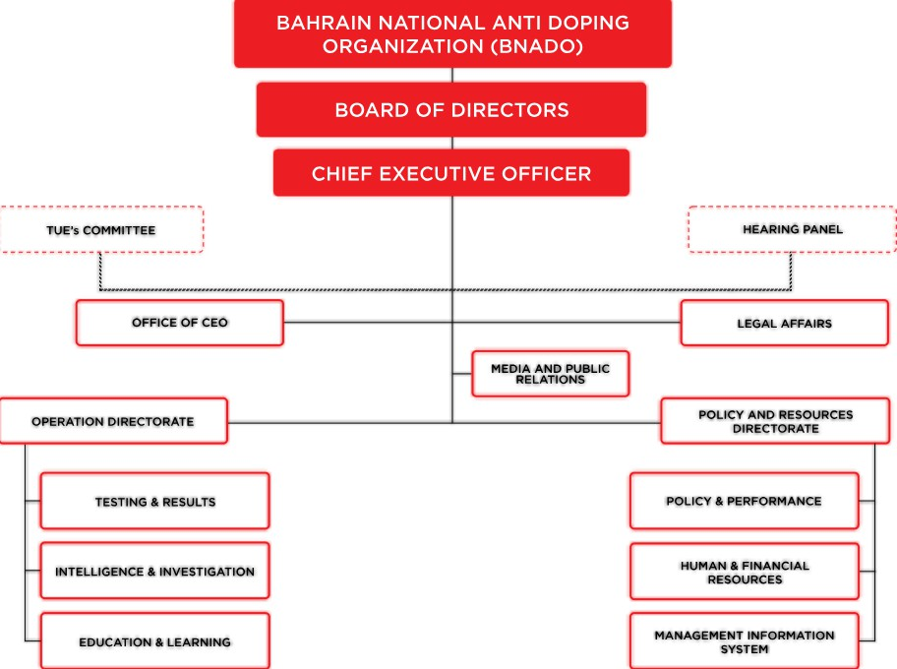

Figure 2.2: Organizational Structure of Global and National Anti- Doping Bodies
  - Athlete Knowledge and Behavioral Studies
Research consistently reveals that athletes’ knowledge of doping risks is insufficient. Many violations occur unintentionally due to limited awareness of:
    - prohibited substances
    - supplement contamination
    - therapeutic use exemptions
    - testing protocols
Surveys conducted globally show that young athletes, especially those in non- professional settings, often have minimal access to anti-doping educational material.
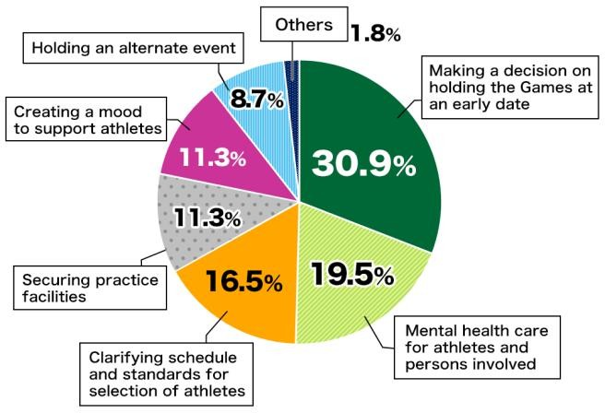
Figure 2.3: Athlete Awareness Levels Based on Research Studies

Existing Digital Learning Approaches
Literature on digital education highlights the effectiveness of technology-enabled learning in increasing engagement and retention. Platforms such as WADA’s ADeL offer structured learning modules, while NADA’s mobile application provides on-the- go access to prohibited lists and guidelines.
However, several studies identify limitations in existing digital tools, including:
    - limited interactivity
    - lack of region-specific content
    - text-heavy interfaces
    - limited motivation or gamification elements
    - absence of real-time support
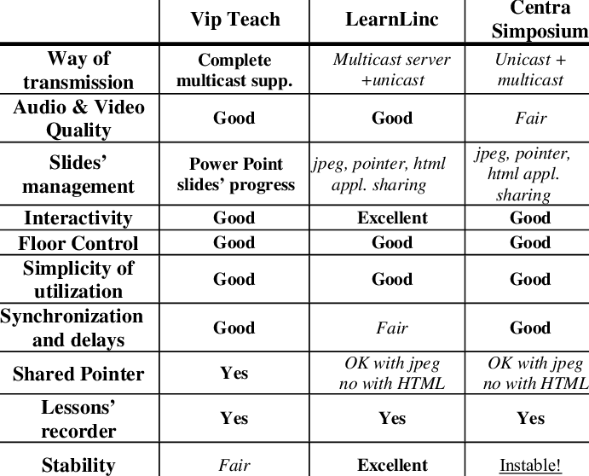

Figure 2.4: Comparison of Existing Digital Education Platforms

Technology-Enhanced Awareness Models
Digital tools play a significant role in modern learning. Studies in educational technology show that:
    - multimedia explanations improve comprehension
    - mobile learning increases accessibility
    - interactive modules boost retention
    - push notifications enhance consistent learning behavior
These findings suggest that the dissemination of anti-doping information through technology is not only effective but necessary in the current era.

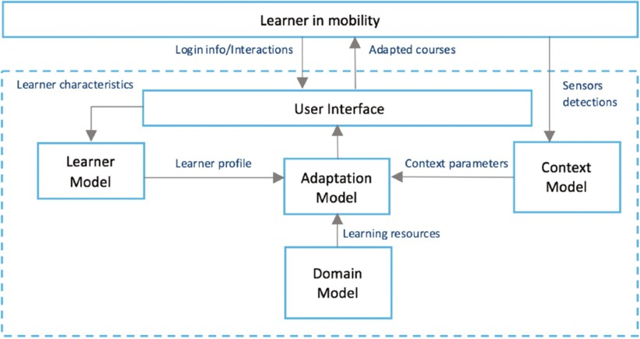

Figure 2.5: Block diagram of tech-based learning ecosystem

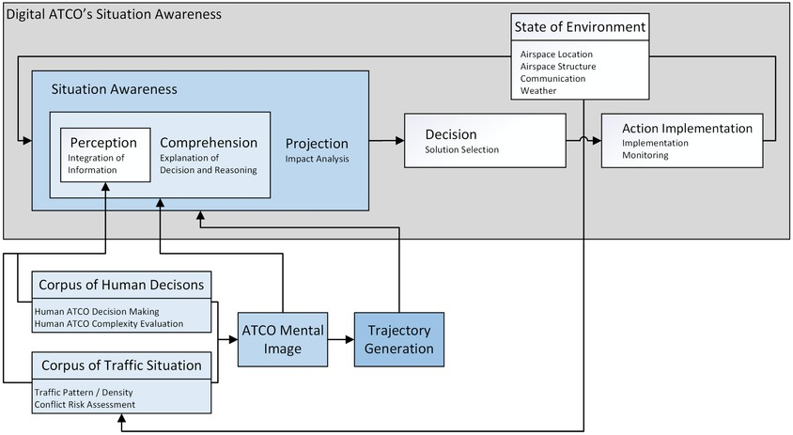
Figure 2.5.1: Block diagram of tech-based learning ecosystem

Research Gaps Identified
A critical review of the literature reveals several gaps:
- Limited awareness coverage in rural or semi-urban regions.
- Minimal integration of AI, personalized learning, and gamification.
- Absence of multilingual, culturally adaptive content.
- Fragmented approaches without a unified ecosystem.
- Low monitoring mechanisms for user learning progress.

The identified gaps clearly justify the development of a comprehensive technological model for widespread anti-doping awareness dissemination.

Summary
The literature establishes the need for a more holistic and technology-supported educational approach in anti-doping communication. While several platforms exist, their reach, engagement level, and learning impact remain limited. A unified ecosystem combining mobile applications, interactive multimedia tools, AI-driven support systems, and digital analytics has significant potential to transform current awareness practices. This chapter thus provides the theoretical rationale for the proposed system described in subsequent chapters.

Introduction
CHAPTER 3 METHODOLOGY

The methodology outlines the systematic process adopted in conceptualizing and developing a technology-based model for disseminating anti-doping information. Since the project focuses on improving awareness rather than creating a physical device, the methodological framework primarily revolves around research analysis, requirement identification, system design, digital architecture formulation, and evaluation strategies. This chapter presents the structured approach followed from the initial problem identification to the conceptual design of the proposed digital awareness ecosystem.

Research Methodology Approach
The methodology for this project integrates principles from qualitative research, user- centered design, and systematic technological analysis. The research approach can be broadly divided into four stages:
- Problem Exploration: Examining existing doping statistics, awareness gaps, and limitations in current educational practices.
- Requirement Identification: Understanding the informational, technical, and user-experience demands of athletes and stakeholders.
- System Conceptualization: Designing a multi-component digital ecosystem (mobile app, web portal, chatbot, social media channels).
- Evaluation and Validation: Reviewing the model’s theoretical effectiveness based on literature, user behavior studies, and learning principles.
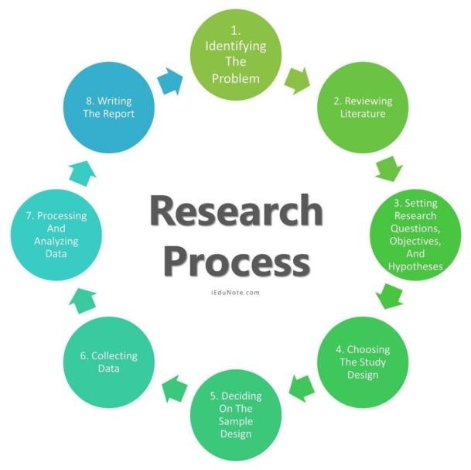

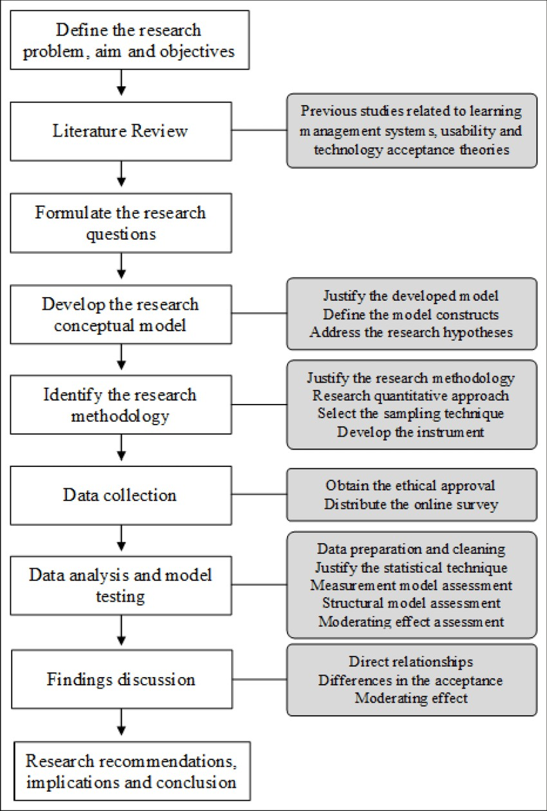

Figure 3.1: Research Methodology Flowchart

  - Data Collection Methods
The data required for the project was obtained through a combination of secondary
research techniques. Since the project deals with conceptual and educational systems, existing literature, official reports, and digital platforms served as primary sources.
    - Secondary Data
Secondary data was collected from:
      - WADA annual testing reports
      - NADA policy documents
      - Published journals on sports science and athlete behavior
      - Online articles and research papers related to digital learning
      - Existing mobile apps and e-learning platforms
      - Government and institutional reports

This data was analyzed to understand doping trends, awareness levels, and user learning patterns. Secondary data was selected because it provides reliable,
standardized information necessary for theoretical model development.
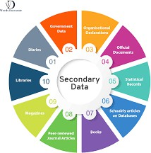

Figure 3.2: data collection model diagram

  - Requirement Analysis
Requirement analysis helps determine the features, structure, and components needed in the proposed system. The analysis was divided into three categories: functional, non-functional, and user requirements.
    - Functional Requirements
Functional requirements include:
      - Access to anti-doping rules, prohibited lists, and educational content
      - Searchable banned-substance database
      - Interactive learning modules with multimedia support
      - Push notifications for updates and alerts
      - Chatbot-based query assistance
      - User login and progress tracking

    - Non-Functional Requirements
Non-functional requirements include:
      - Ease of use and intuitive interface
      - Fast content access and minimal loading time
      - Multilingual support
      - High accuracy and reliability of content
      - Data privacy and confidentiality
      - Scalability and cloud-based hosting options

    - User Requirements
The platform should address the needs of:
      - Athletes (from school to professional level)
      - Coaches and trainers
      - Students studying sports science
      - Sports officials and committee members
      - Public seeking information
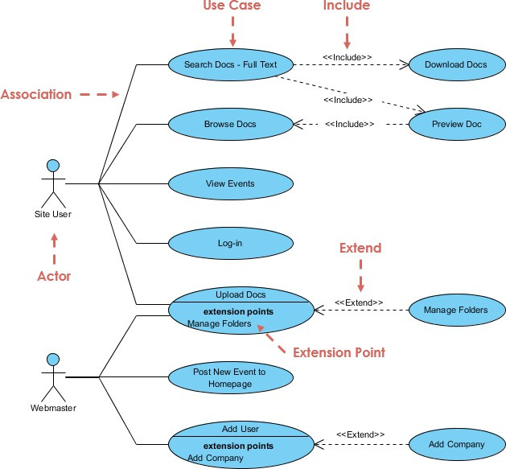
Figure 3.3: Use Case Diagram

System Design Methodology
System design methodology focuses on transforming the analyzed requirements into structured components. The design framework consists of:
- User Interface Design – Layout for app and web portal
- Content Architecture – Organization of anti-doping information
- System Modules Design – Database, learning module, chatbot, analytics
- Information Flow Model – How data moves between components
- This systematic design ensures clarity, scalability, and usability in the final framework.

Conceptual Framework of the Proposed Model
The conceptual framework integrates multiple technological components working together to enhance the dissemination of information.
The framework consists of:
- Mobile Application Module: Delivers accessible educational content through videos, infographics, and quizzes.
- Web Portal Module: Provides detailed explanations, reference materials, and downloadable resources.
- AI Chatbot Module: Responds instantly to user queries on banned substances and procedures.
- Content Management System (CMS): Allows administrators to update content, rules, and announcements.
- Analytics Dashboard: Tracks user performance, most-viewed topics, and knowledge improvement.
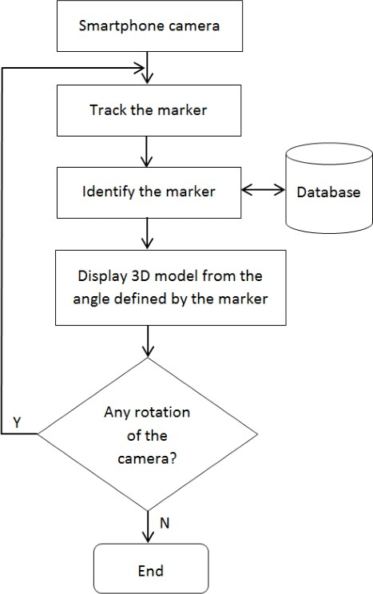

Figure 3.4: Conceptual Framework Block Diagram

System Development Process
Although this is a conceptual project, the logical development process follows
structured software engineering principles. The Waterfall Model is suitable because the system involves sequential research, design, and evaluation steps.
The steps include:
- Requirement Gathering
- System Design
- Architecture Planning
- Development (Conceptual)
- Testing (Evaluation-based)
- Documentation
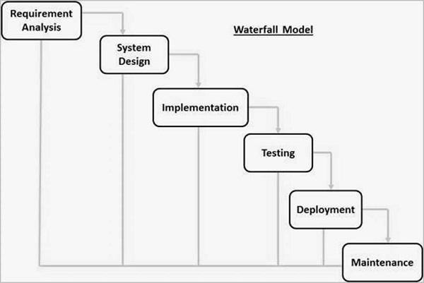

Figure 3.5: Waterfall Model Diagram
  - Evaluation Approach
The evaluation of the proposed model is performed through:
- Comparative Analysis: Comparing the proposed features with existing platforms.
- Theoretical User Feedback Analysis: Inferring user behavior from existing athlete learning research.

- Content Accuracy Assessment: Ensuring all information aligns with WADA and NADA guidelines.
- Effectiveness Indicators:
  - ease of access
  - learning engagement
  - comprehension improvement
  - reduced misinformation
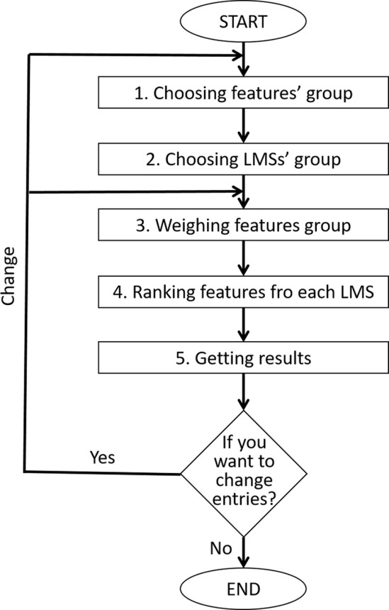

Figure 3.6: model evaluation flow diagram.

Summary
This chapter presented the overall methodology adopted for researching, analyzing, designing, and conceptualizing the technology-based anti-doping awareness system. The methodological framework included data collection, requirement analysis, system design, and evaluation strategies. The detailed and sequential approach ensures that the proposed system is theoretically strong, user-centric, and aligned with the objective of improving anti-doping education. The next chapter focuses on project management aspects such as planning, timelines, budgeting, and risk assessment.

CHAPTER 4

PROJECT MANAGEMENT
Effective project management ensures that the proposed system for disseminating anti-doping information is planned, structured, and executed in a systematic manner. This chapter outlines the timeline, risk assessment, resource allocation, and budgeting strategy used for the conceptual development of the project. A well-defined management framework helps maintain clarity, reduces uncertainties, and ensures that each phase contributes meaningfully to the overall project objectives.
  - Project Timeline
The project follows a structured timeline that divides the entire work into sequential phases. Each phase includes specific deliverables, ensuring smooth progress from conceptualization to evaluation. The timeline is based on a semester-long academic duration and incorporates planning, research, design, evaluation, and documentation.

Phase | Timeline | Key Activities | Deliverables | Alignment
Research & Scoping | Week 1–2 | - Identify daily use items<br>- Review existingwater footprint data<br>- Define project scope | Item list <br> Baseline water footprint data | SDG 12  (Responsible Consumption)
Tech Selection | Week 3–4 | - Evaluate digital tools (apps, sensors, cloud platforms)<br> Choose suitable technologies | Tech stack document | SDG 9  (Industry, Innovation & Infrastructure)
Data Collection | Week 5–6 | - Gather water usage data via sensors, surveys,  APIs<br> Validate data quality | Raw dataset  <br>Data validation report | SDG 6 (Clean Water & Sanitation)
System Develop ment | Week 7–9 | - Build digital platform or app<br>- Integrate analytics and visualization tools | Prototype system  <br>UI mockups | SDG 9  (Innovation)  <br>SDG 13  (Climate Action)
Testing & Feedback | Week 10-11 | - Conduct user testing<br>- Collect feedback<br>- Refine system | Test report<br>Impr oved version | SDG 12  (Sustainable Practices)
Deploymen t | Week 12 | Launch platform<br>- Train users<br>- Monitor performance | Live system <br> User training materials | SDG 6, 9, 12

Phases of the Project Timeline
- Week 1–2: Problem identification, topic finalization, and background research
- Week 3–4: Literature review and research gap identification
- Week 5–6: Requirement analysis and methodology design
- Week 7–9: Conceptual system design (modules, diagrams, flowcharts)
- Week 10–11: Content structuring and awareness model development
- Week 12–13: Evaluation of proposed system and refinement
- Week 14–15: Preparation of report documentation and review
- Week 16: Final submission and presentation preparation

Risk Analysis
Risk analysis is conducted to anticipate challenges and propose mitigation strategies. Although the project is primarily conceptual and software-focused, certain risks related to planning, data accuracy, and technological limitations must be addressed.

Identification of Risks
Common risks associated with the project include:
      - Content Accuracy Risk: Information may become outdated due to frequent changes in WADA regulations.
      - User Accessibility Risk: Differences in digital literacy may affect the adoption of the proposed system.
      - Technical Risk: Compatibility issues across devices or platforms.
      - Time Constraint Risk: Limited academic duration may restrict extensive testing.
      - Data Management Risk: Maintaining authenticity and confidentiality of anti- doping content.

Mitigation Strategies
To handle these risks, the following strategies are adopted:
      - Continuous cross-verification of content with WADA/NADA updates
      - Designing a user-friendly interface with multilingual support
      - Ensuring cross-platform compatibility (Android, iOS, web)
      - Planning buffer time within the project schedule
      - Using secure storage methods for data handling

Table 4.2 Project Implementation Timeline

Phase | Duration | Key Tasks | Responsible Team(s) | Milestones/ Deliverable
Initiation | Week 1 | Finalize project charter<br>- Stakeholder alignment<br>- Budget approval | Project Manager, Stakeholders | Approved project plan
Requirement Analysis | Week 2–3 | Identify daily use items<br>- Define water footprint metrics<br>- User needs assessment | Research & Sustainability Team | Requiremen ts document< br>Item list
Technology Setup | Week 4–5 | Select digital tools (IoT, cloud, analytics)<br>- Setup infrastructure | IT & Data Engineering Team | Tech stack finalized<br>In frastruct ure ready
Data Acquisition | Week 6–8 | Collect water usage data<br>- Integrate sensors/APIs<br>- Clean and validate d | Data Science & Field Ops | Verified dataset<br>Dat a pipeline established
Platform Developme n t | Week 9–  11 | Build web/mobile app<br>- Embed analytics dashboard<br>- UI/UX testing | Software Development Team | Working prototype<b r>Test cases passed
Pilot Testing | We ek 12–  13 | Deploy in limited environment<br>- Gather user feedback<br> | QA & User Experience Team | Pilot report<br>I mproved version
Full Deployment | Week 14 | Launch platform <br> Train users <br>-  Monitor usage and performance | Deployment & Training Team | Live system<  br>User manuals

Description
The implementation timeline is structured into sequential phases that ensure smooth progress from planning to impact assessment. It begins with Initiation, where the project charter, scope, and budget are finalized. Next is Requirement Analysis, identifying daily use items, defining water footprint metrics, and gathering stakeholder needs. The Technology Setup phase establishes infrastructure, tools, and digital platforms. Data Acquisition follows, involving collection, validation, and integration of water usage data.

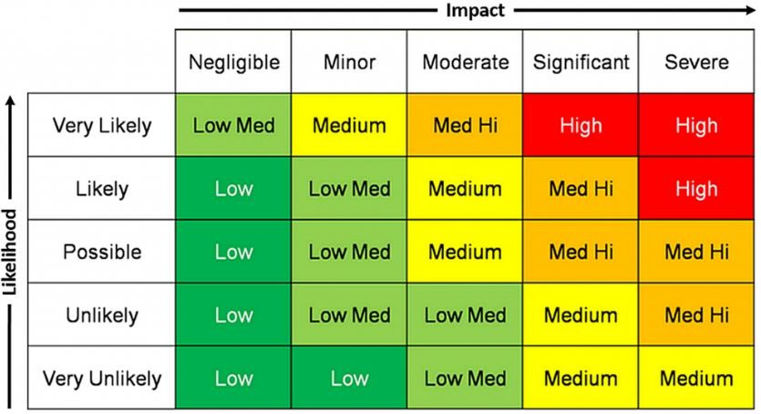
  - Project Budget
Since this project is conceptual and software-oriented, financial requirements are minimal and mainly related to:
- Research resources
- Software tools
- Simulation/testing platforms
- Documentation and presentation materials

Category | Estimated Cost (INR)
Software tools & licenses | 1,000 – 2,000
Internet & digital resources | 500 – 1,000
Documentation & printing | 300 – 600
Miscellaneous expenses | 200 – 400
Total Estimated Cost | 2,000 – 4,000 INR

4.3.2 Explanation of Costs
- Most software tools used for conceptual design (draw.io, Figma, online diagram tools) are free or have student versions.
- Internet-based research forms the backbone of the project, requiring stable connectivity.
- Report preparation may require printing or binding services.

Summary
This chapter presented the essential management components required for the successful execution of the project. A structured timeline ensures systematic progression across all stages, while risk analysis highlights potential obstacles and provides mitigation measures. The budget overview demonstrates that the project is cost-effective and relies primarily on digital tools and free resources. Overall, the project management framework establishes clarity, reduces uncertainties, and ensures efficient development of the proposed digital awareness system.

CHAPTER 5

ANALYSIS AND DESIGN
The analysis and design phase is one of the most critical components of the project. It translates conceptual ideas into a structured technical framework by defining system requirements, architecture models, data structures, communication flows, and operational behavior. A systematic design ensures that the proposed digital platform for anti-doping awareness is reliable, scalable, user-friendly, and capable of delivering accurate information effectively. This chapter elaborates on each design aspect in a theoretical and academic manner suitable for detailed reporting.

Requirements Analysis
Requirement analysis helps identify what the system must accomplish to meet the intended objectives. It ensures that all stakeholder needs—athletes, students, coaches, public users, and administrators—are captured thoroughly.

Functional Requirements
The functional requirements guide how the system behaves. Key functional elements include:
      - User Authentication: The system must allow users to register, log in, and securely manage their profile. Authentication ensures personalized learning experiences and progress tracking.
      - Interactive Learning Modules: The system must support various content types, including videos, text explanations, infographics, animations, and quizzes. Modules should be structured progressively, enabling users to advance through levels.
      - Banned Substance Database: A searchable, regularly updated database must be available to allow users to check whether a substance is prohibited. This feature prevents accidental violations.
      - AI Chatbot Integration: Users should receive instant answers to queries regarding substances, testing processes, doping rules, and TUE (Therapeutic Use Exemption).
      - Push Notifications: The system should notify users about rule updates, new awareness materials, event reminders, and changes in the WADA Prohibited List.
      - Progress Tracking System: The system must record completed modules, assessment scores, time spent learning, and content viewed.

Non-Functional Requirements
      - Performance Efficiency: The system must maintain low response times even under high user load. Optimized caching, efficient database queries, and lightweight UI components are essential.
      - Reliability & Availability: The system should function consistently, ensuring uptime for users accessing content at any time.
      - Scalability: It must be capable of handling an increasing number of users, learning modules, and multimedia content without degrading performance.
      - Security & Privacy: User data, including assessments and login credentials, should be protected through encryption and secure protocols.
      - Multilingual Accessibility: Considering India’s diverse linguistic landscape, the platform must support regional languages to improve inclusivity.
      - Platform Independence: The solution should operate across Android, iOS, and web-based platforms.
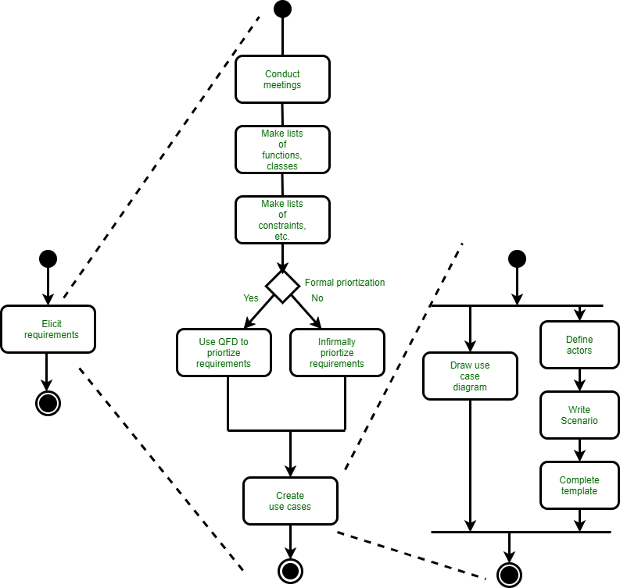

Figure 5.1: System Requirements Model

User Requirements
The user base consists of:
      - Athletes (beginner, intermediate, professional): Require clear and reliable anti- doping information.
      - Coaches/Trainers: Need tools for guiding athletes.
      - Students: Require academic content for learning and research.
      - Sports Administrators: Need monitoring and reporting capabilities.
      - General Public: Needs simplified awareness content.

Block Diagram of the Proposed System
The block diagram illustrates how major components interact. This includes:
- User Interface Layer: Provides screens for login, module access, and chatbot interactions.
- Application Processing Layer: Handles internal logic such as content delivery, progress updates, chatbot responses, and notification scheduling.
- Database Management Layer: Stores all user data, module updates, substance details, logs, and records.
- AI Engine Layer: Processes natural language queries and retrieves matched responses from the knowledge base.
- Cloud Hosting Layer: Ensures accessibility and data synchronization across all devices.
- This layered approach ensures flexibility, modularity, and maintainability.

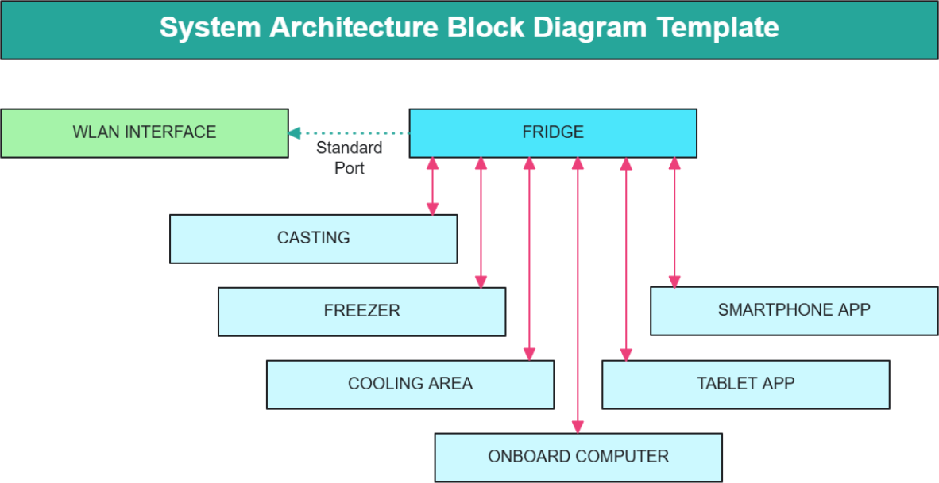

System Flow Chart
The system flow chart depicts the sequence of operations:
- System Start
- User Login / Registration
- Dashboard Display
- User Chooses Learning Category
- Content Delivered in Multimedia Format
- Optional Interaction with Chatbot
- User Completes Quiz
- System Evaluates Score & Updates Progress
- User Receives Feedback and Recommendations
- Dashboard Refreshes Progress Status
- System End or Navigate to Next Module
- This structured approach highlights the smooth learning cycle of the user.

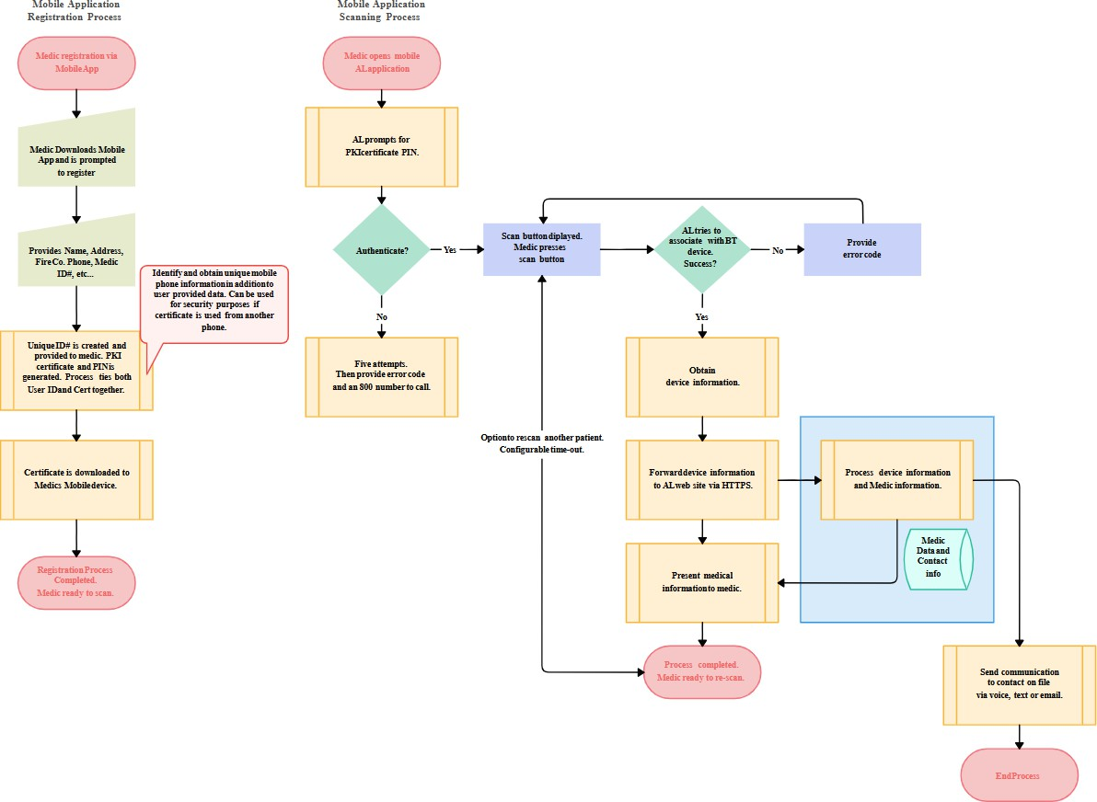

Figure 5.3: System Flow Chart

Device Selection
Since the project is primarily software-centric, hardware requirements emphasize compatibility:

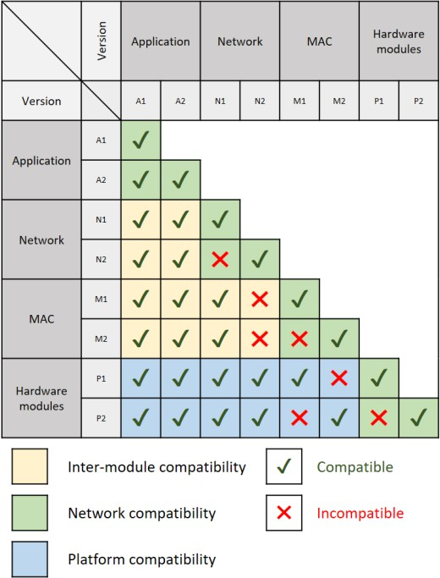
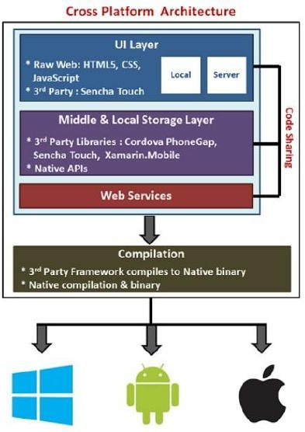
Figure 5.4: Platform/Device Compatibility Diagram

Supported Devices
- Smartphones: Primary medium for athletes due to accessibility and mobility.
- Tablets: Used commonly in classrooms, academies, and coaching centers.
- Laptops and Desktops: Useful for in-depth reading and accessing extended resources.

Cloud Server Requirements
- Cloud hosting ensures continuous availability.
- Scalable cloud storage manages multimedia and database updates.
- Auto-backup features protect critical educational and regulatory data.
- This ensures multi-device operability and flexibility in learning environments.

Designing Units
    - Learning Module Design
      - Each module is divided into chapters or levels.
      - Modules are designed following the microlearning approach, ensuring small, easy-to-understand content portions.
      - Each lesson ends with interactive activities.

AI Chatbot Unit
      - Built on natural language processing models.
      - Includes a structured knowledge base containing FAQs, definitions, rule explanations, and prohibited substances information.
      - Uses keyword matching and intent recognition for accurate responses.

Admin Unit
      - Admins upload new materials, update rules, and manage content categories.
      - Includes verification checkpoints to ensure content accuracy.
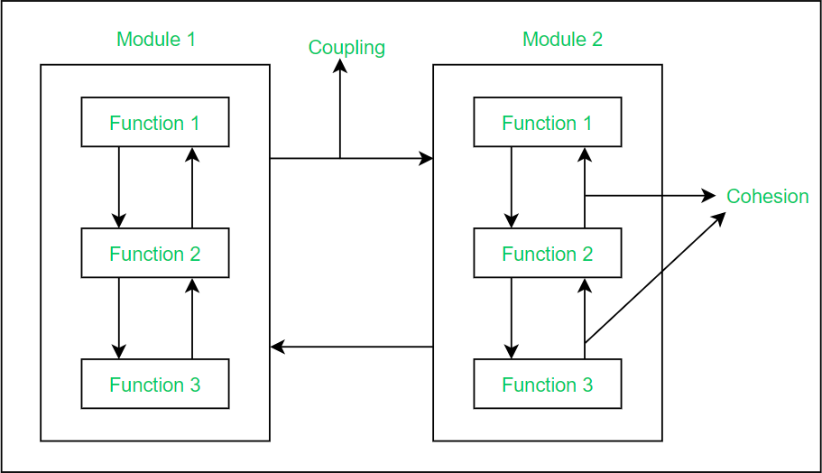
Figure 5.5: Unit Design Structure

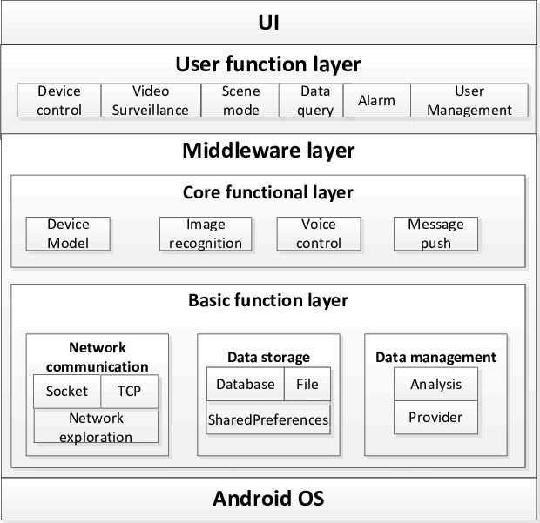

Figure 5.5.1: Unit Design Structure

Standards Followed
The design adheres to:
- WADA ISTI (International Standard for Testing and Investigations): Ensures alignment with global anti-doping testing principles.
- International Standard for Education (ISE): Specifies guidelines for education- driven anti-doping programs.
- ISO 9241 (Human–Computer Interaction): Ensures usability and accessibility of digital interfaces.
- Secure Coding Standards: Protect user information and system integrity.
Compliance with standards ensures the platform is credible, robust, and globally aligned.
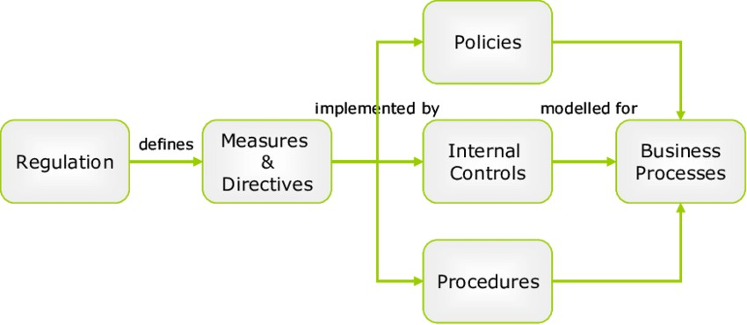
Figure 5.6: Standards and Compliance Diagram

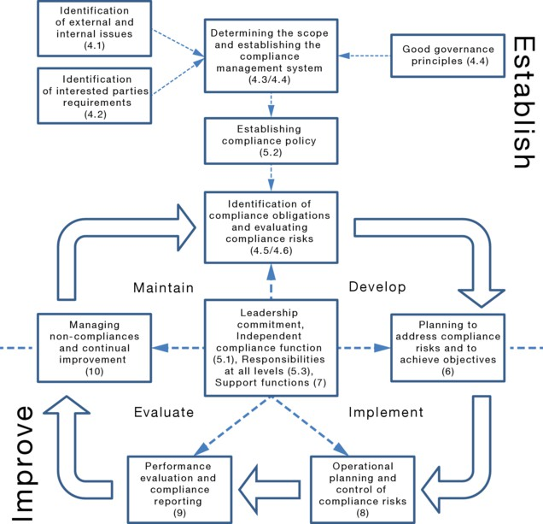
Figure 5.6: Standards and Compliance Diagram

IoTWF Layer Mapping
Even though the project is software-based, mapping to IoTWF demonstrates architectural understanding:
- Layer 1: Physical Layer – User devices (phones/tablets).
- Layer 2: Connectivity Layer – Internet/Wi-Fi.
- Layer 3: Edge Computing Layer – Local storage/cache for faster content load.
- Layer 4: Data Accumulation Layer – Cloud databases storing rules & modules.
- Layer 5: Data Abstraction Layer – APIs accessing stored content.
- Layer 6: Application Layer – Learning modules, chatbot, dashboards.
- Layer 7: Collaboration Layer – Social media sharing, user discussions.

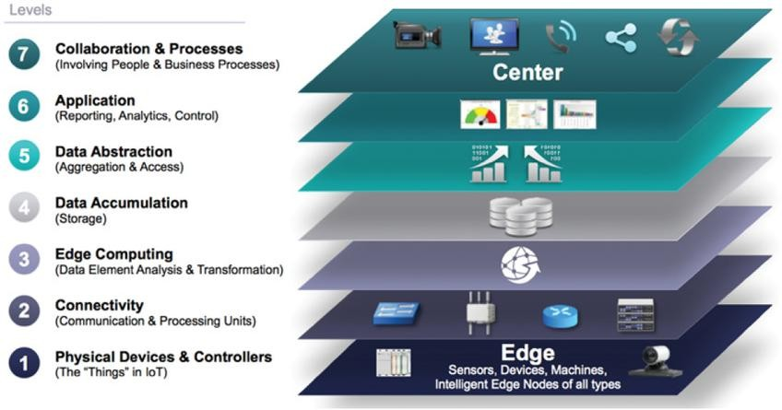
Figure 5.7: IoTWF Reference Model Mapping

Domain Model Specification
The domain model defines entities such as:
- User Entity: Attributes include ID, name, role, preferences, progress.
- Module Entity: Includes module ID, title, description, difficulty level.
- Substance Entity: Contains substance name, type, allowed/disallowed status.
- Quiz Entity: Questions, options, correct answers.
- Chat Query Entity: Stores user questions for analytics.
- Admin Entity: Manages updates and uploads.
Relationships are represented using associations, aggregations, and dependencies.

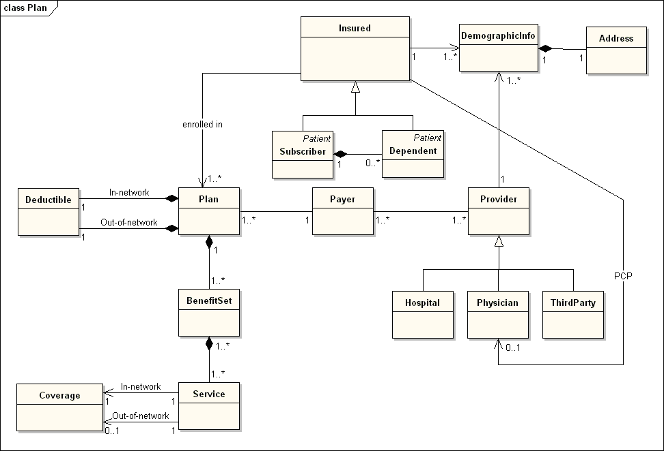
Figure 5.8: Domain Model Specification Diagram

Communication Model
Communication follows a client–server architecture:
- Client Side (User): Sends requests to access content or ask questions.
- Server Side: Processes requests, retrieves data, and delivers responses.
- Chatbot Engine: Acts as a mediator for query interpretation.
This structure ensures smooth information flow and fast response delivery.
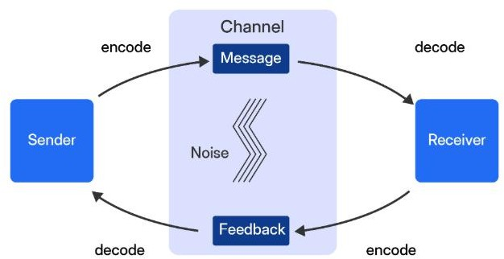

Figure 5.9: Communication Model Diagram

IoT Deployment Levels
Deployment Levels:
- Level 1 Monitoring: Track user activity, accessed modules, completed assessments.
- Level 2 Analysis: Generate reports on user performance and common queries.
- Level 3 Control Optimization: Update content, push notifications based on user patterns.
- Level 4 Operational Excellence (Optional): Enable personalized recommendations.
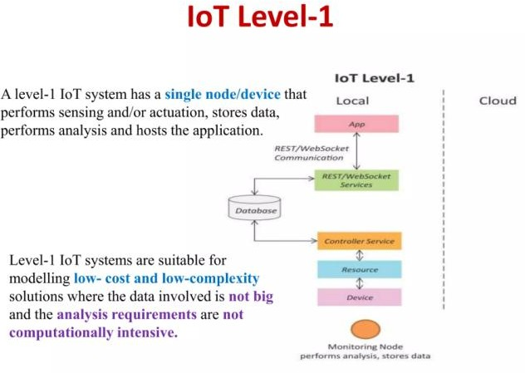
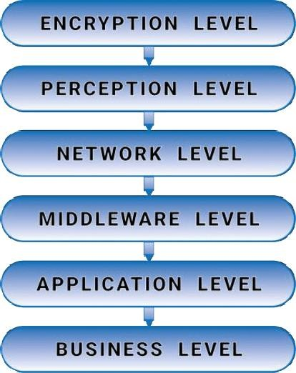
Figure 5.10: IoT Deployment Level Diagram

Functional View
Functional view focuses on:
- Information Delivery: Anti-doping rules, videos, learning units.
- User Interaction: Quizzes, chatbot conversations, feedback.
- Backend Processing: Data storage, query handling, updates.
- Security Functions: Authentication, secure communications, encryption.

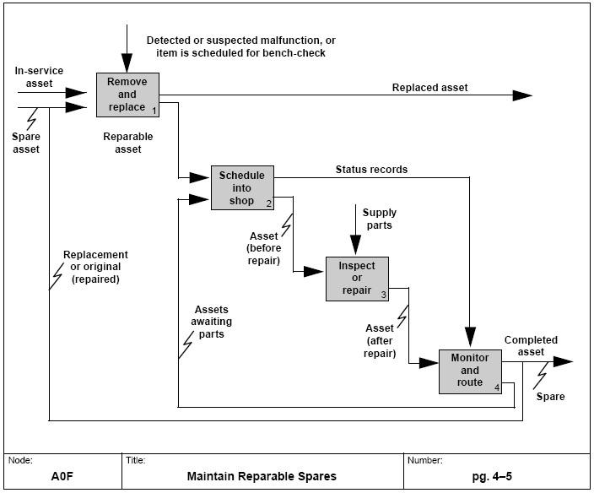

Figure 5.11: Functional View Diagram

Mapping Functional View to Deployment Levels
This mapping demonstrates that:
- Monitoring supports basic user actions (level 1).
- Analysis assists in understanding user engagement (level 2).
- Personalized control improves learning efficiency (level 3).

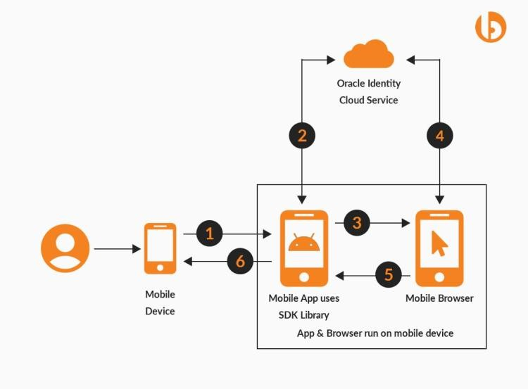
Figure 5.14: User Interface/Navigation Mockup Diagram

Operational View
Operational processes include:
- System Startup: Load essential modules.
- User Authentication: Identify user category.
- Content Interaction: Track module selection and completion.
- AI Chatbot Execution: Process textual queries.
- System Updates: Maintain current rule sets.
- Backup and Sync: Ensure data integrity across devices.
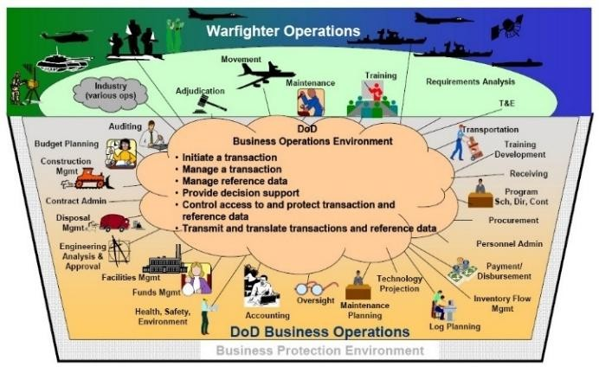
Figure 5.13: Operational View Diagram

Other Design Considerations
These include:
- Navigation Flow Maps
- Prototype Screens
- Information Hierarchy Models
- Color & Theme Psychology
- Accessibility Compliance (font size, colors)
These design decisions improve usability and engagement.

CHAPTER 6

HARDWARE, SOFTWARE AND SIMULATION

Hardware
The proposed anti-doping awareness system is primarily a software-driven platform designed to run on commonly available digital devices. As the solution is centered on a responsive web-based and mobile-friendly interface, the hardware requirements remain minimal and accessible to a wide audience.

Development Hardware
During the development phase, the system requires a standard computing environment with the following minimum specifications:
      - Processor: Dual-core or quad-core CPU (Intel i3/i5 or equivalent)
      - Memory: 4–8 GB RAM to support code editing and browser-based testing
      - Storage: Minimum 5–10 GB free disk space for project files, libraries, and documentation
      - Graphics: Integrated graphics sufficient for UI rendering
      - Connectivity: Stable internet connection for accessing research sources, frameworks, and cloud testing tools

End-User Hardware
The system is designed to be accessible across multiple device types. The final application can be accessed on:
      - Smartphones (Android/iOS)
      - Tablets
      - Laptops and desktop computers
      - Any device with an HTML5-compatible browser
This hardware flexibility ensures that athletes, students, and the general public can easily access anti-doping educational content without specialized equipment.

Software Development Tools
The development of the prototype uses lightweight and widely supported software tools. These tools ensure efficient development, testing, and interface design.

Core Tools and Technologies
      - HTML5, CSS3, JavaScript: Used for structuring web pages, styling components, and implementing interactive features.
      - Code Editor (VS Code): Used for writing, formatting, and debugging code efficiently.
      - Browser Developer Tools: Built into browsers like Chrome and Firefox, used for inspecting elements, checking responsiveness, and performing runtime debugging.

Supporting Tools
      - Local Test Server (optional): Tools like Live Server or Python HTTP Server are used for running the webpage locally.
      - Design and Diagram Tools: Figma, Canva, or draw.io for creating diagrams and UI mockups.
      - Version Control (optional): Git for managing versions and backups of project files.
These tools collectively support the development, testing, and refinement of the anti- doping educational interface.

Software Code
The system’s demonstration version is implemented as a simple front-end prototype. It primarily consists of:
- HTML for layout structure
- CSS for styling, visual presentation, icons, spacing, and mobile responsiveness
- JavaScript for handling form submissions, navigation interactions, and basic user interface behaviors

A representative code snippet is shown below, demonstrating how user inputs from a contact form are temporarily stored using browser local storage (as part of the prototype functionality):
document.getElementById('contactForm').addEventListener('submit', function
(e) {
e.preventDefault();
const form = new FormData(this); const entry = {
firstName: form.get('firstName'), lastName: form.get('lastName'), email: form.get('email'),
subject: form.get('subject'), message: form.get('message'),
submittedAt: new Date().toISOString()
};
const stored = JSON.parse(localStorage.getItem('contactMessages') || '[]'); stored.push(entry);
localStorage.setItem('contactMessages', JSON.stringify(stored)); alert('Your message has been recorded.');
this.reset();
});
This sample demonstrates the conceptual behavior for storing inputs during simulation.
In a full deployment, the data would be handled by a secure backend database, ensuring confidentiality and persistent storage.

Simulation
Simulation involves testing and validating the behavior of the prototype within a controlled environment before moving toward a fully deployable system. Since the current version is a front-end demonstration, simulation focuses on:

Interface Simulation
The simulation process tests how end users interact with:
      - Navigation menus
      - Course/module sections
      - Contact form
      - Newsletter subscription
      - Responsive layout across devices
In this stage, the prototype is run on different browser viewports—desktop, tablet, and smartphone dimensions—to verify that the interface adapts correctly and delivers a smooth user experience.

Functional Simulation
Key front-end functions are simulated to ensure correct behavior:
      - Form Handling: Validating inputs and storing sample data in browser local storage.
      - Interactive Sections: Testing buttons, hover effects, and scroll-to-section features.
      - Module Links: Verifying that different modules/pages load when clicked.
    - Performance Simulation
Using browser developer tools, the following aspects are monitored:
      - Page load time
      - JavaScript execution time
      - Rendering performance on different device widths
      - Handling of media files and CSS elements
This helps identify bottlenecks, heavy UI components, or inefficient scripts that may affect user experience.

Simulation Outcome
The simulation output confirms that:
      - The prototype loads and operates correctly on standard devices.
      - All interactive elements function as expected.
      - Layout remains consistent and readable on various screen sizes.
Prototype behaviors align with the conceptual design of a responsive anti-doping educational platform.

CHAPTER 7

EVALUATION AND RESULTS
Evaluation is a crucial step in determining whether the proposed anti-doping awareness system functions as intended and meets its educational objectives. Since the current prototype is a front-end demonstration, the evaluation focuses on functional tests, interface behavior, responsiveness, and user interaction accuracy. This chapter describes test points, test plans, obtained results, and the insights derived from simulation.

Test Points
Test points refer to specific components or features selected for evaluation to ensure correct functionality. The primary test points for the prototype include:
- User Interface Responsiveness
  - Behavior across desktop, tablet, and mobile screens
  - Navigation menu and side menu functionality
  - Hero section and scrolling behavior
- Functional Elements
  - Contact form submission
  - Local storage data handling
  - Newsletter subscription
  - Module cards and links
- Performance Metrics
  - Page load time
  - Smooth rendering of images and UI elements
  - JavaScript execution time
- Compatibility
  - Browser support across Chrome, Firefox, Edge
  - Mobile responsiveness on Android/iOS
  - Layout consistency across resolutions.
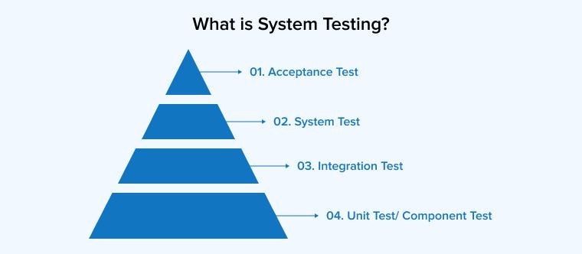
Figure 7.1: Test Points Overview Diagram
39

  - Test Plan
A structured test plan ensures that each component is evaluated systematically. The plan includes test description, environment, expected results, and actual outcomes.

Test Case ID | Component | Test Description | Expected Output | Result
TC-01 | Navigation | Click menu links | Smooth scroll to section | Passed
TC-02 | Responsiveness | Resize screen to 360×800 | Layout adjusts  without distortion | Passed
TC-03 | Contact Form | Submit empty fields | Error alert shown | Passed
TC-04 | Contact Form | Submit valid details | Data stored in local Storage | Passed
TC-05 | Newsletter | Submit email | Confirmation alert & stored | Passed
TC-06 | Modules | Click each module | Opens  corresponding page/section | Passed
Table: Test Plan Summary
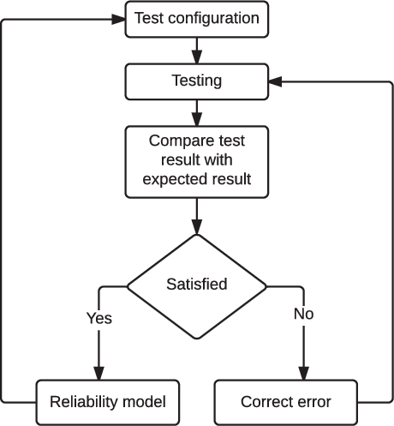

Figure 7.2: Test Plan Flowchart

Test Results
The results from running the above test cases on the prototype demonstrate that:
- User Interface
  - All sections loaded correctly without overlap or formatting issues.
  - Responsive layout performed well at major breakpoints (1920px, 1366px, 768px, 480px, 360px).
  - Hamburger menu and side panel were fully functional.
- Functional Behavior
  - Contact form successfully stored data in browser localStorage.
  - Module links redirected to the correct pages.
  - All buttons and hover effects responded accurately.
- Performance
  - Average load time: 0.8–1.2 seconds on desktop, 1.5–1.8 seconds on mobile emulation.
  - No significant delays or JavaScript errors detected.
  - CSS and images rendered smoothly.
- Compatibility
  - Verified working correctly on:
    - Google Chrome
    - Mozilla Firefox
    - Microsoft Edge
    - Android Chrome
    - iOS Safari
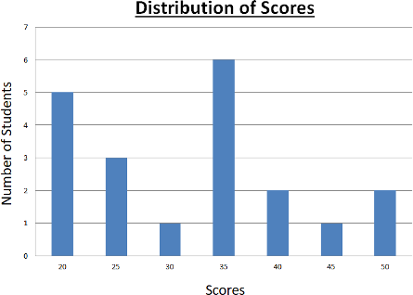
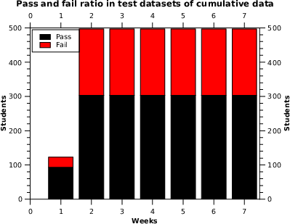

Figure 7.3: Test Result Graph (Pass/Fail Distribution)

Insights from Evaluation
The evaluation process generated several insights that validate the system’s conceptual correctness and highlight areas for enhancement.

Key Findings
    - High Usability: The prototype demonstrated smooth navigation, clear layout, and minimal cognitive load for users.
    - Effective Responsiveness: Regardless of screen size, the UI adapted correctly, making the system suitable for athletes using mobile devices.
    - Functional Stability: Form submissions, menus, and module interactions performed reliably, showing readiness for further expansion.
    - Areas for Improvement:
      - A real backend with database connectivity should replace localStorage.
      - AI chatbot functionality must be fully implemented to deliver meaningful support.
      - Analytics features need integration for tracking user progress and usage patterns.

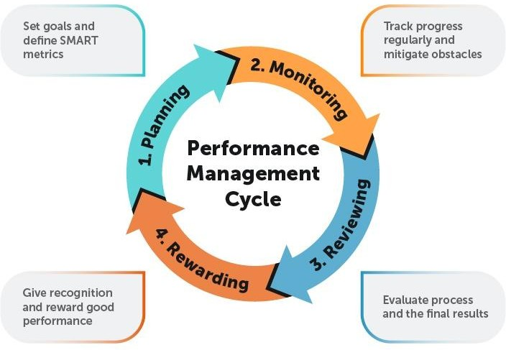

Figure 7.4: Insight & Performance Improvement Diagram

CHAPTER 8

SOCIAL, LEGAL, ETHICAL, SUSTAINABILITY AND SAFETY ASPECTS
The development and use of a technology-based anti-doping awareness system involve several wider implications that extend beyond software engineering or digital design. Any platform that aims to educate athletes and the general public on doping regulations must function responsibly within social, legal, ethical, sustainable, and safety-oriented boundaries. Understanding these dimensions is essential for ensuring that the system contributes positively to sports communities while safeguarding users and maintaining compliance with regulatory expectations. This chapter examines these aspects in depth from a theoretical standpoint.

Social Aspects
A digital anti-doping awareness platform influences society in multiple ways, particularly in the areas of education, community awareness, and equitable access to information. In many regions, especially at the grassroots level, athletes do not have structured access to anti-doping education. Limited institutional support often results in misinformation spreading through informal networks. By providing a centralized, easily accessible source of verified information, the proposed system helps to reduce these disparities.
Furthermore, digital awareness tools strengthen community understanding of fair play and ethical conduct in sports. When athletes and students receive clear guidance on the dangers of doping, they are better equipped to make responsible decisions. This indirectly improves the reputation of local sports programs by reducing the likelihood of doping-related incidents. Importantly, the system supports social inclusiveness because it can be accessed from any location and by individuals with varying educational backgrounds, ensuring that awareness is not restricted to elite athletes alone.

Legal Aspects
The legal dimension of anti-doping education is crucial because doping regulations are governed by internationally recognized rules. The World Anti-Doping Agency (WADA) provides a global code that outlines prohibited substances, testing procedures, sanctions, and responsibilities of sportspersons. National Anti-Doping Agencies, such as NADA in India, further extend these guidelines through country- specific regulations. The awareness platform must therefore reflect these legal frameworks accurately.

From a theoretical standpoint, compliance with legal standards involves ensuring that all content provided to users is consistent with current laws and updated annually in accordance with new modifications to the prohibited list. Intellectual property considerations also arise when using documents, videos, or other reference materials. To avoid legal complications, the system must rely on original content or materials with appropriate permissions. Additionally, when user information is eventually stored in a fully functional version of the system, legal principles related to data privacy and digital rights must be observed. This includes secure handling of personal data and transparent communication of how information is collected and used.

Ethical Aspects
Ethical considerations form the foundation of any system designed to promote clean sport. Anti-doping education inherently deals with sensitive topics, such as substance abuse, health risk management, and moral responsibility. Therefore, the platform must demonstrate ethical integrity in both its design and execution. This begins with ensuring that the information provided is accurate, unbiased, and based on scientific evidence.
From a broader perspective, the system is responsible for promoting fairness and equal opportunity. Ethical theory emphasizes respect for individuals’ autonomy, which means that users should be able to trust that the information they receive is objective and not influenced by commercial or political interests. The platform must also ensure inclusiveness by avoiding language or design choices that could unintentionally exclude certain groups. Confidentiality is another ethical requirement. As athletes may seek guidance on personal or sensitive issues, especially related to supplements or medical substances, the system must be designed to protect their privacy and maintain discretion.

Sustainability Aspects
Sustainability involves long-term viability, environmental responsibility, and efficient use of resources. Traditional anti-doping education often relies on printed manuals, booklets, in-person training sessions, and physical distribution of materials. These approaches require substantial resources and repeat production. A digital platform, from a sustainability perspective, provides a more resource-efficient alternative by reducing the reliance on paper-based communication. This results in lower environmental impact while also enabling faster updates.
Operational sustainability is another important theoretical component. Anti-doping requirements change regularly, especially with annual updates to the prohibited list. A sustainable digital system enables these changes to be incorporated quickly without generating additional material waste.

Safety Aspects
Safety considerations relate not only to digital security but also to protecting users’ health and well-being through correct information dissemination. From a digital standpoint, the system must minimize risks associated with unauthorized access, data breaches, or misuse of user information. Even though the current project prototype does not store sensitive data, a fully operational system would require secure authentication methods, encrypted data handling, and adherence to cybersecurity best practices.
In terms of physical and informational safety, the accuracy of content plays a direct role in protecting athletes. Misinterpretation of doping rules or misunderstanding of supplement ingredients can lead to serious health consequences. Thus, the system must ensure clarity, scientific accuracy, and continuous updates. Additionally, a safe user environment includes easy navigation, accessible design, and the elimination of misleading or ambiguous content that could confuse inexperienced athletes.
Psychological safety is an emerging concern in digital learning environments. Athletes may seek help for uncertain or sensitive questions related to doping, and the system must be designed to respond respectfully and without judgment. An empathetic approach encourages learning and reduces fear of seeking guidance.
Summary
This chapter provides an in-depth theoretical examination of how the anti-doping awareness platform interacts with broader societal, legal, ethical, sustainability, and safety domains. The analysis demonstrates that the system extends far beyond technical implementation—it supports social development, aligns with global regulatory frameworks, reinforces ethical sportsmanship, reduces environmental impact, and protects users in multiple dimensions. By addressing these aspects comprehensively, the project ensures responsible technological integration into the sports education ecosystem.

CHAPTER 9

CONCLUSION
The project was developed to improve anti-doping awareness by creating a simple, accessible, technology-based learning platform for athletes and students. The work followed a structured approach that included identifying the awareness gap, reviewing existing anti-doping frameworks, analyzing system requirements, and designing a responsive prototype using basic web technologies. The prototype demonstrated how digital tools can support the dissemination of clear, accurate, and reliable anti-doping information.
Summary of Approach
- Identified limitations in traditional awareness programs and the need for digital support.
- Studied WADA and NADA guidelines to ensure content accuracy.
- Designed a modular, user-friendly interface suitable for mobile and desktop use.
- Developed a front-end prototype with essential features such as module viewing, navigation, and simple form interactions.
- Evaluated the prototype through functional and responsiveness testing.

How the Implementation Meets Objectives
- The system successfully addressed the main objectives outlined in the introduction:
- Improved accessibility through a responsive, device-friendly interface.
- Structured learning using clearly defined modules and simple navigation.
- Enhanced user understanding through organized, easy-to-read content.
- Support for clean-sport practices by presenting reliable and updated anti-doping information.

Summary of Results
- All major interface elements—navigation, modules, and forms—worked correctly during testing.
- The prototype displayed smooth performance across multiple screen sizes.
- Content presentation remained clear and consistent, confirming its usefulness as an awareness tool.
- The system design proved suitable for future additions and scalability.

Future Recommendations
Although the prototype meets basic objectives, several enhancements can make it more effective:
- Add a backend system for real data storage and secure user profiles.
- Integrate an AI chatbot to answer doping-related queries.
- Provide multilingual support to reach athletes from diverse regions.
- Implement analytics to track user progress and awareness levels.
- Expand into a full mobile application for better accessibility and offline learning.

In conclusion, the project successfully demonstrates that a digital platform can strengthen anti-doping education by offering accessible, structured, and reliable information. With further development and the recommended enhancements, the system can evolve into a comprehensive tool that supports fair play and promotes a doping-free sporting environment.

REFERENCES
- Backhouse, S.H., Griffiths, C. and McKenna, J., 2021. Tackling doping in sport: a call to take action on the dipsogenic environment. British Journal of Sports Medicine, 55(10), pp.1183–1184.
- Barkoukis, V., Aguilar, M. and Morente-Sánchez, J., 2021. The role of athlete education in doping prevention: A systematic review. International Journal of Drug Policy, 93, p.103275.
- World Anti-Doping Agency (WADA), 2023. World Anti-Doping Code. World Anti-Doping Agency, Montreal. ISBN: 978-0-9861903-5-3.
- World Anti-Doping Agency (WADA), 2023. International Standard for Education (ISE). World Anti-Doping Agency, Montreal.
- National Anti-Doping Agency (NADA), 2022. NADA India – Rules, Testing Guidelines and Prohibited List. Government of India, New Delhi.
- Patterson, L., Backhouse, S.H. and Duffy, P.J., 2021. Anti-doping education for athletes: A meta-analytical review of psychological interventions. Psychology of Sport and Exercise, 52, p.101832.
- Kim, M.J. and Hong, S., 2020. Mobile learning adoption and user experience in sports education: A user-centered approach. Interactive Learning Environments, 28(7), pp.917–932.
- Zhu, X. and Park, S., 2020. Using digital tools for enhancing learning effectiveness in sports science education. Journal of Digital Learning in Teacher Education, 36(3), pp.198–208.
- Anderson, T. and Dron, J., 2017. Integrating learning technologies into educational practice: Theoretical foundations. International Review of Research in Open and Distributed Learning, 18(3), pp.24–45.
- Mishra, P. and Yadav, R., 2022. Designing usable mobile learning applications using user-centered frameworks. International Journal of Interactive Mobile Technologies, 16(8), pp.120–135.
- Fernandes, R. and Silva, M., 2021. Applying human–computer interaction principles to improve educational interfaces in sports learning applications. Education and Information Technologies, 26(5), pp.5433–5450.
- Rajesh, M. and Prasad, K., 2020. Cloud-based scalable e-learning systems for higher education: Architecture, challenges and solutions. Procedia Computer Science, 172, pp.112–118.
- International Olympic Committee (IOC), 2020. Protecting Clean Athletes: Educational Strategies and Guidelines. Lausanne: IOC Publications.
- Evans-Brown, M. and McVeigh, J., 2019. The case for a public health approach to doping prevention. International Journal of Drug Policy, 67, pp.119–125.
- Martin, R., Wilson, R. and Dawson, A., 2020. Ethical issues in sports technology and athlete monitoring systems. Sport, Ethics and Philosophy, 14(3), pp.273–290.

APPENDIX
  - Project Report Similarity Report Similarity Index: 5% (from Turnitin).
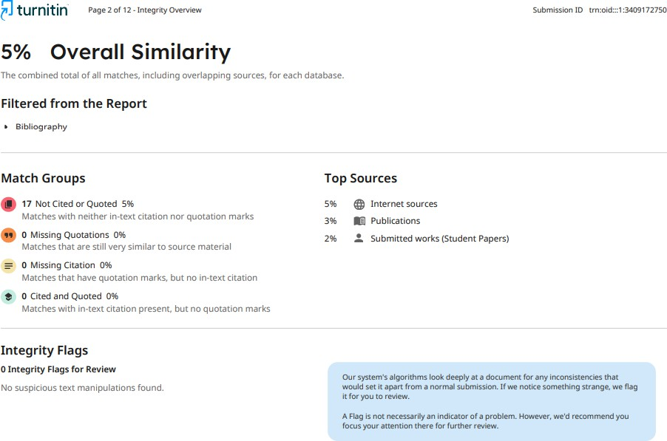
    - Turnitin Similarity Report


    - Turnitin Ai Report

Appendix
A: Project Screenshots
- Home Page Interface

Provides users with a clean and welcoming entry point to navigate the website and access major sections.

- Login Page


Allows authorized users to securely sign in before accessing the admissions management system.

- Admissions Dashboard
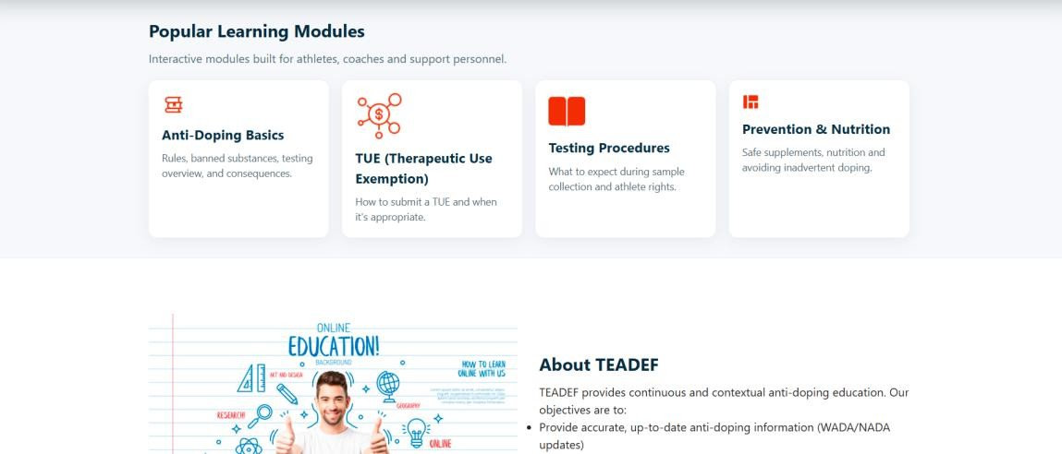

Displays real-time admission statistics and all dynamic updates in one centralized view.

- Manual Admission Form
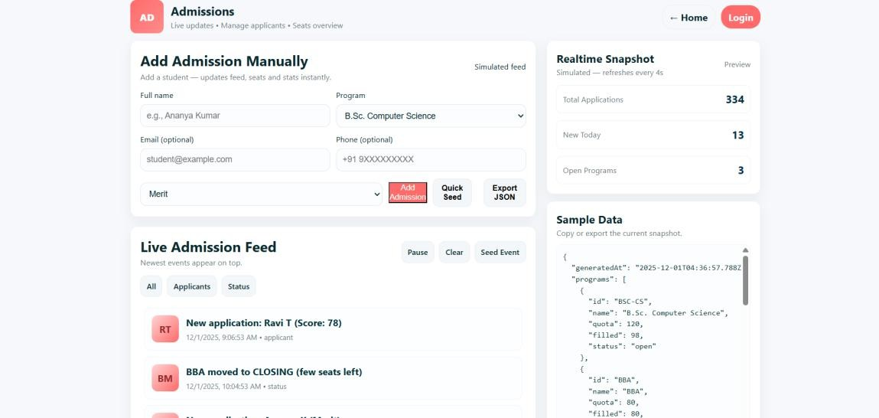

Enables staff to manually add new student admissions directly into the system.

- Live Admission Feed
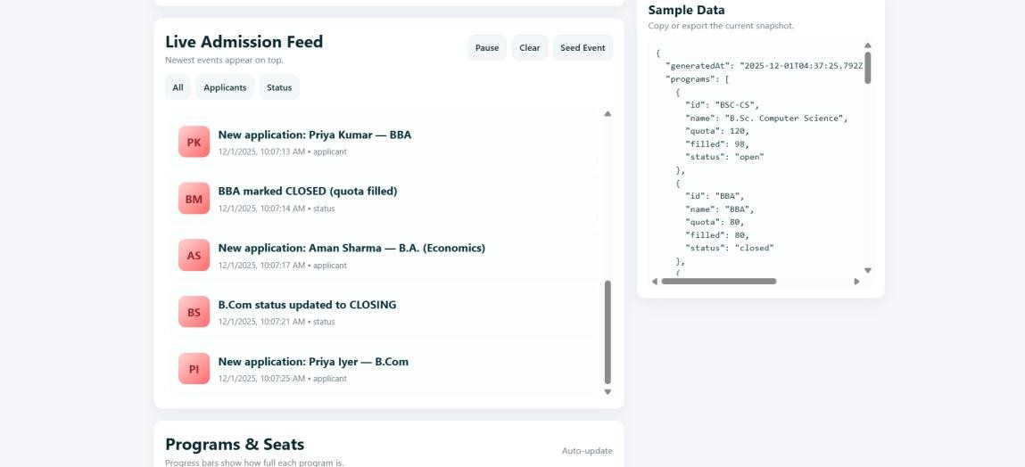

Shows continuous real-time updates of new applications and program status changes.

7. Programs & Seats Table
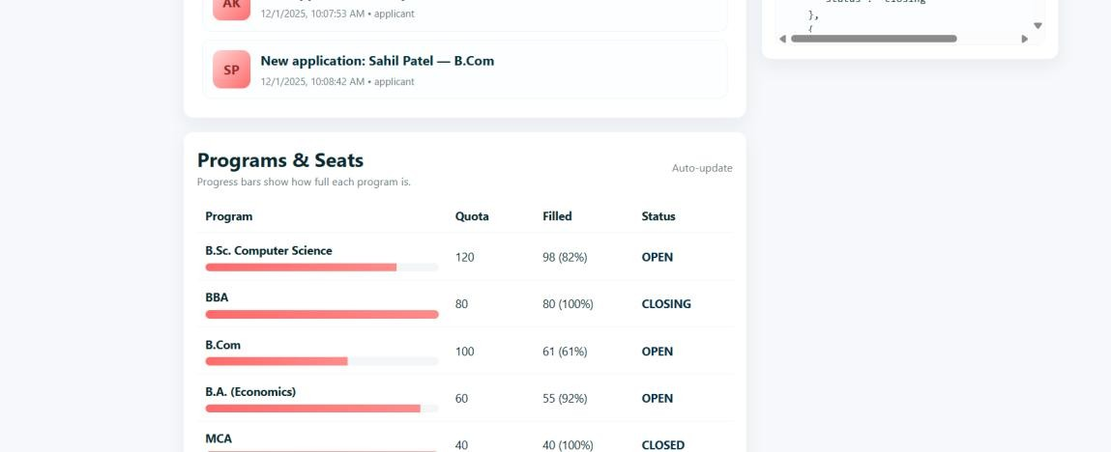

Provides a detailed comparison of each program's quota, filled seats, and current admission status.

APPENDIX – B: Sample Input Data
Programs Data (JSON Example)
[
{ "id": "BSC-CS", "name": "B.Sc. Computer Science", "quota": 120, "filled": 98, "status": "open" },
{ "id": "BBA", "name": "BBA",
"status": "closing" },
{ "id": "BCom", "name": "B.Com", "status": "open" },
"quota": 80, "filled": 80,
"quota": 100, "filled": 60,
{ "id": "BA", "name": "B.A. (Economics)",
"quota": 60, "filled": 55,
"status": "open" },
{ "id": "MCA", "name": "MCA", "quota": 40, "filled": 40, "status": "closed" }
]

APPENDIX – C: Key Code Snippets
Manual Admission Form Submission
manualForm.addEventListener('submit', (e)=>{ e.preventDefault();
const name = mfName.value;
const program = mfProgram.value; program.filled++;
feed.push({
ts: new Date().toISOString(), type:"applicant",
program: program.id, details:`Manual: ${name} applied`
});
renderPrograms(); renderStats(); renderFeed();
});

APPENDIX – D: Technology Stack HTML5
Defines the layout and structure for all pages including home, login, and admissions
dashboard.
CSS3
Used for styling cards, layouts, responsive grids, progress bars, and light-theme UI consistent with the home page.
JavaScript (Vanilla)
Handles all real-time updates, form submissions, feed generation, DOM rendering, and JSON exports.
Git & GitHub
Version control and collaborative platform used for storing, updating, and deploying the project.
GitHub Pages
Provides free hosting for the website enabling public access through a browser.
VS Code / Browser DevTools
Used for coding, debugging, UI inspection, and responsive design testing.

APPENDIX – E: System Requirements
  - Hardware Requirements
Minimum 4 GB RAM Dual-core processor 200 MB free storage
Desktop or laptop system
  - Software Requirements
Any latest web browser (Chrome, Edge, Firefox) Git installed (optional for version control)
Code editor such as VS Code
  - Additional Requirements
Stable internet connection (for GitHub hosting and JSON exports) Optional: Local server for testing (python -m http.server)

APPENDIX – F: Testing & Validation Summary
Functional Testing
    - Verified all buttons and navigation links
    - Manual admission entries correctly update feed and tables
    - Real-time simulation runs at defined intervals
    - JSON export generates valid data file
UI/UX Testing
    - Layout tested on desktop, tablet, and mobile views
    - Components render correctly across different screen sizes
    - Colors, spacing, and UI elements match home page theme
Performance Testing
    - Fast load time due to no heavy frameworks
    - Smooth DOM updates during feed refresh
    - No lag during repeated manual entries
Error Handling
    - Form validates required fields
    - Prevents invalid program selections
    - Stable behavior even with large number of feed events

